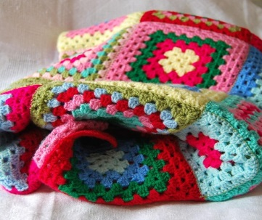
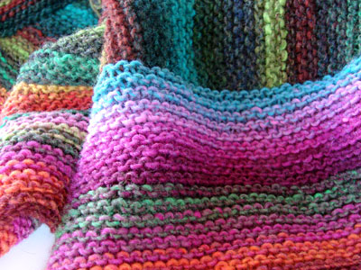
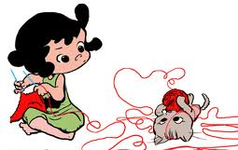
Knit And Natter

Do you like knitting or crochet?
Do you want to learn how to knit or crochet?
Then why not join our new group
Bring your own wool, needles or crochet hook
Starting
4th March 2014
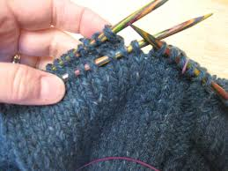
Where:
Would you like to knit blanket squares or baby coats for charity
Barking Methodist Community
Centre
Short Blue Place
(Nr MacDonalds)
Time: 10.30-12 noon
Donations for postage etc
Tea and Cakes provided
For more info:
Call: 02085940752
Or
Email: barkingmethodist@outlook.com

